CAB-00042 – Wired Motor – Orbita
Ver. | Date | Pub | Chk | Description
A1 | 24/01/2023 | EB | AC | Initial drawing.
B1 | 27/03/2023 | EB | AC | Now using Hall sensors

Description
24V BLDC Motor (+Reduction + Encoder) wired for Orbita.

Bill of Material
Item | Description | L (mm) | Qtté | Ref. Farnell / RS
BLDC Motor 24V + Reductor + Encoder | ECXTQ22M+GPX22R1C+ENX22 |  | 1 | Provided par Pollen
Molex PicoBlade Fem. Housing 5 ways | 51021-0500 |  | 1 | /
Contacts for PicoBlade | 50079-8000 |  | 5 | /
Molex MicroFit Fem. Housing 3 ways | 43645-0300 |  | 1 | /
Contacts for MicroFit | 46235-0001 |  | 3 | 2284551 /
Gaine thermo

Assembly
Molex PicoBlade Contacts are crimped with the Molex 63811-0000 Tool.
Molex MicroFit Contacts are crimped with the Molex 64016-0201 Tool.

Drawing

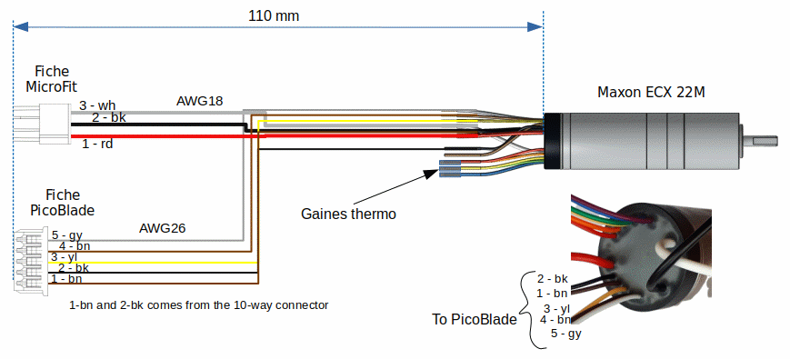
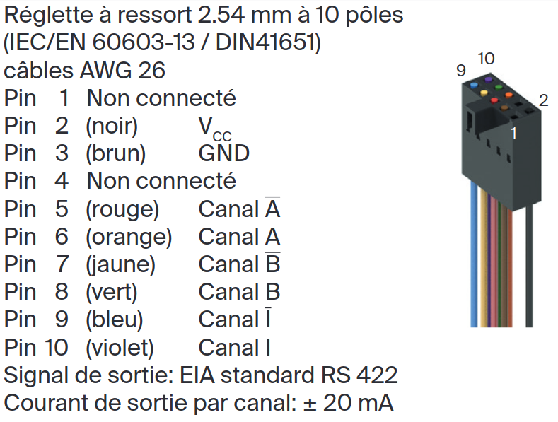
Nota
Please note that the wires 1-brown and 2-black must be taken from the 10-way connector pin #2 and #3.

